|  |  |
| --- | --- |
|  | Information Technology Department State Polytechnic Of Malang, Indonesia **Jobsheet-1: Introduction Of Database Database**  Created By: Database Teaching Team  *FEBRUARI 2024* |

# Topics

Concepts And Databases

# Purpose

College Student:

1. Understanding The Concept Of Data And Databases
2. Knowing The Application Database In Mysql DBMS
3. Understanding The Example Of Duplication And Inconsistency Of Data On Database
4. Able To Display A Diagram Of The Database, And The Contents Of The Table
5. Being Able To Add Data To The Table And Find Out The Errors In The Addition Of Data
6. Knowing The Function Of The Relation Between Tables

# Preliminary

**Understanding Data**

Data Is A Representation Of Real-World Facts That Represent An Object That Is Recorded In The Form Of Numbers, Letters, Symbols, Text, Images, Sounds, Or Combinations Thereof.

Sample Data To Consumer Goods Sales Data:

* There Are Two Sales To Three Different Customer And On A Different Date.
* Sales 1 Was Carried Out On The Date February 1, 2016 To Buy Two Kinds Of Goods, The First Item Is A Notebook Of 5 Pieces @ A $ 5 Thousand. The Second Is A Pencil Item 2 Pieces @ Worth Three Thousand.
* Penjulan 2 Is Done On The Date February 2, 2016 To Buy One Kind Of Goods, Namely Pencils 3 Pieces @ $ 2 Thousand

Data Is Sourced. The Processed Data Will Be Information That Is Important For Companies And Organizations. Examples Of The Data Stored Product Sales Every Day, And Recapitulate The Obtained Information Such As:

* 1. Income Information Store Every Day, Every Week, Every Month Or Every Year,
  2. Increase Or Decrease In Earnings Information Even Earnings Each Period,
  3. Information About The Products Most Widely Sold,
  4. Information On The Number Of Sales, Etc.

The Information Is Used And Needed By The Company Or Organization To Expand Its Business As Determining Which Products Should Be Plenty In Stock For Increased Sales Means Increased Profits. If The Company Does Not Have The Data Then Do Not Get The Information The Company Will Not Last Long Or Losses And Bankruptcy.

In Order For A Company Or Organization To Get Information That Is Important For The Survival Of Their Business, Then The Required Data. To Prevent Data Loss, Easy To Use, And Valid Need To Be Treated In A Manner In Order To Neatly, Made Archival Records, Categorized And Stored In A Place That Facilitate The Search. The Conventional Way Is The Filing Cabinet. More Modern Way Is To Store In Computer Files (In A Spreadsheet). More Modern Again Is Stored In The Database.

# Database

"Database" (Database) Is Derived From A Combination 2nd Term Base / Base Is Headquarters / Warehouse, Where Nesting / Gathering. And The Data Are Real-World Representations Of Facts That Represent An Object That Is Recorded In The Form Of Numbers, Letters, Symbols, Text, Images, Sounds, Or Combinations Thereof. The Object In Question Here Are Human (Employees, Students, Clients, Customers), Goods, Animals, Events, Concepts, State, And So On.

Definition Databases From Multiple Points Of View:

1. The Set Of Data Groups (Archives) That Are Interconnected Organized In Such A Way So That Later Can Be Recovered Quickly And Easily.
2. A Collection Of Interrelated Data Stored Together In Such A Manner And Without Repetition (Redundancy) Are Not Necessary, To Meet The Various Needs.
3. A Collection Of Files / Tables / Archive Interconnected Stored In Electronic Storage Media.

In The Database Data Is Stored In A Table-Table Interconnected Without Repetition (Redundancy) That Do Not Need To Be Used Again Correctly, Quickly And Easily.

Examples Of Sales Database:

Table Sales

|  |  |  |  |  |  |
| --- | --- | --- | --- | --- | --- |
| **Date** | **Name** | **Price** | **Amount** | **Cashier** | **Total Sales** |
| February 1st, 2016 | Notebooks | 5000 | 5 | Doni | 31000 |
| Pencil | 3000 | 2 |
| February 2nd, 2016 | Pencil | 3000 | 2 | Doni | 6000 |

Figure 1 Sales Table

In Figure 1 Shows That There Are Two Sales Transactions, Where The First Sale (Date Of February 1, 2016) Sold 2 Kinds Of Goods, While The Second Sale Of Goods Sold 1. The Table Can Not Be Implemented In The Database Because The Database In The Form Of Tables Where Each Table Has A Row With The Same Number Of Columns (Number Of Rows Or Columns Can Not Be Combined). So If You Want To Implement In The Database Need To Be Modified As Follows.

Sales Table

|  |  |  |  |  |  |
| --- | --- | --- | --- | --- | --- |
| **Date** | **Name Of Goods** | **Price** | **Amount** | **Cashier** | **Total Sales** |
| February 1st, 2016 | Notebooks | 5000 | 5 | Doni | 31000 |
| February 1st, 2016 | Pencil | 3000 | 2 | Doni | 31000 |
| February 2nd, 2016 | Pencil | 3000 | 2 | Doni | 6000 |

Figure 2 Table 1 Sales Table Sales Table

|  |  |  |  |  |  |  |  |  |
| --- | --- | --- | --- | --- | --- | --- | --- | --- |
| **date** | **Item Name**  **1** | **Name**  **Item 2** | **Price 1** | **Price 2** | **number**  **1** | **number 2** | **Cashier** | **total Sales** |
| February 1st, 2016 | Notebooks | Pencil | 5000 | 3000 | 5 | 2 | Doni | 31000 |
| February 2nd, 2016 | Pencil |  | 3000 |  | 2 | 2 | Doni | 6000 |

Figure 3 Table 2 Sales Table

Figures 2 And 3 Is A Modification Of Table Sales Of Goods (Figure 1). The Second Table Could Have Been Implemented Into The Data Base Because Not Violate The Rules In The Formation Table Ie No Columns Or Rows Are Merged. There Is Some Problem From Table Above Which Are:

In The Table Of Sales (Figure 2) There Is No Duplication Of Data That Is Data Cashier Names And Total Sales Will Be Repeated As Many Kinds Of Items Purchased On Every Purchase. Duplication Of Data Causes:

1. Inconsistency Of Data, Where The Cashier And Total Sales Name May Be Different In The Data With The Same Sales Date
2. Confusion, If There Is Data That Is Inconsistent

While The Sales Table (Figure 3) There Is A Lot Of Value In The Blanks. There Will Be Difficulties If On A Sale Of Goods Sold More Than 2 Types. Based On The Two Problems Above, The Correct Table To Store Sales Data Of Goods Are As Follows.

Table Goods

Sales Table

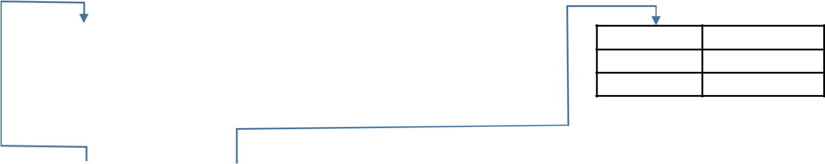

1. Note book
2. Penci

|  |  |  |  |
| --- | --- | --- | --- |
| **Sales code** | **date** | **Cashier** | **total Sales** |
|  | February 1st, 2016 | Doni | 31000 |
|  | February 2nd, 2016 | Doni | 6000 |

|  |  |
| --- | --- |
| **Item code** | **Name** |

Details Table Sales

|  |  |  |  |
| --- | --- | --- | --- |
| **Sales Code** | **Item Code** | **Price** | **Amount** |
| 1 | 1 | 5000 | 5 |
| 1 | 2 | 3000 | 2 |
| 2 | 2 | 3000 | 2 |

Figure 4 Correct Form Of Sales Table

In Figure 4 The Table Sales Of Goods Made Into 3 Tables So That The Problems Can Be Resolved. Figure 4 Is An Overview Of The Database. There Are Several Tables That Are Interconnected Plus Some Other Characteristics (Will Be Described In The Next Jobsheet).

# Prerequisites Practicum

* 1. Students Have Installed The Latest Version Of XAMPP.
  2. XAMPP Already Confirmed Running Correctly.

# Instructions Practicum

1. Perform All The Steps Practicum.
2. Create Screenshot Job You Have Done As Well As The Answers Of Questions That You Answer In A Report In PDF Format!

# Practicum 1

Objective: Add A Database Penjualan_Produk The Mysql DBMS.

# Steps

1. Run Apache And Mysql In XAMPP Control Penel.
2. Run The Application Phpmyadmin On Your Web Browser.Create A New Database By Clicking The New Menu In The Left Corner, Or Click The Tab Databases. Then Click Create Database. Write In The Text Box With The Word Penjualan_Produk Database Name. Then Click Create. Then It Would Appear The Database With The Name Penjualan_Produk.

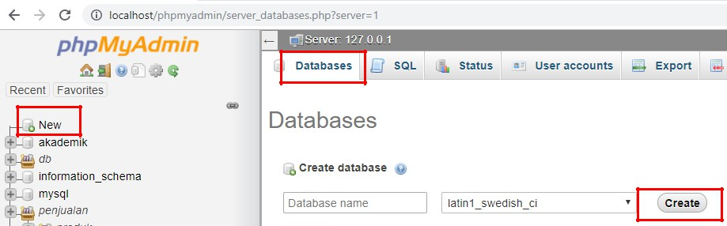

1. Restore Database Penjualan_Produk Of Penjualan_Produk.Sql File. How: Click The Import Tab, Then Click Choose File, Select The File Penjualan_Produk.Sql Taken With This Jobsheet. Click Go Button In The Bottom Of The Page.

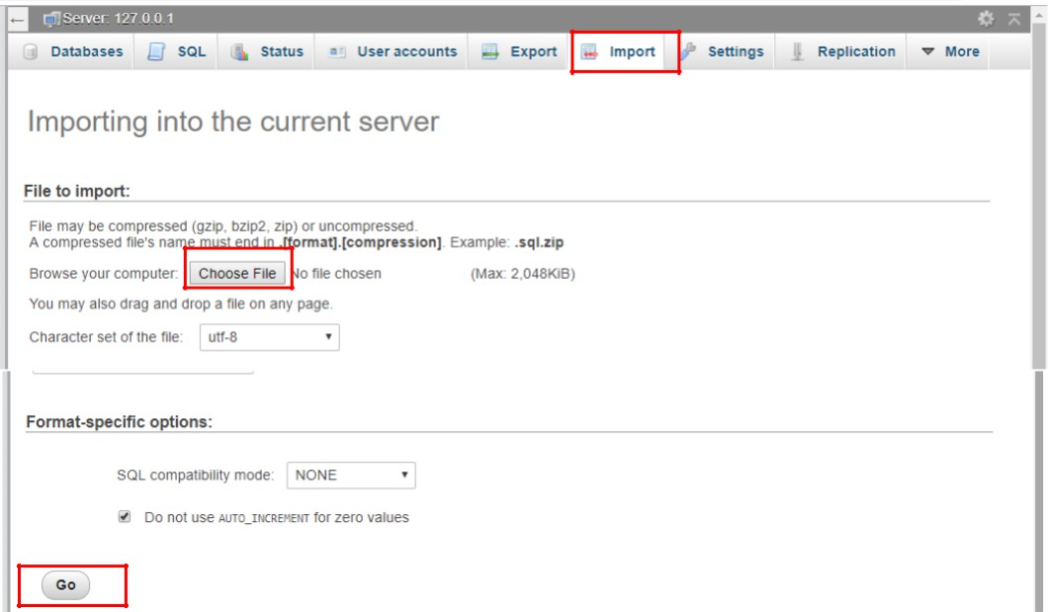

1. If It Is Successful, Database Penjualan_Produk Will Be Created And The Database Name Will Appears In The List Of Existing Data Base On The Left

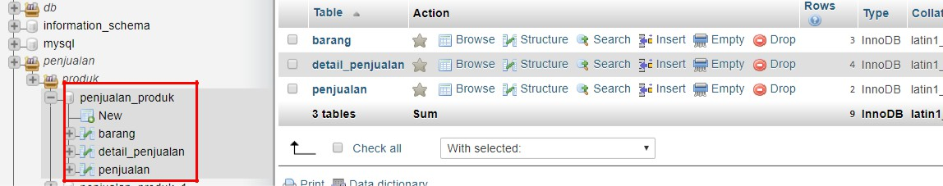

# Practicum 2

Objective: To Show Diagrams Database, And The Contents Of The Table.

# Steps

1. To Display A Diagram Of The Data Base's How: Click The Name Of The Database And Then Select The Tab More, Select The Menu Designer.
2. To View The Contents Of The Table How To Click The Name Of The Table. Then The Data In The Table Will Appear On The Right.

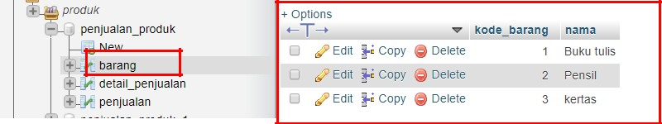

# Practicum 3

Objective: Add Data To The Table And Find Out The Errors In The Addition Of Data.

# Steps

1. To Add Data To The Sales Table-Click A Table Name, Then Select The Insert Tab, Enter The Value In Each Column, And Click Go.

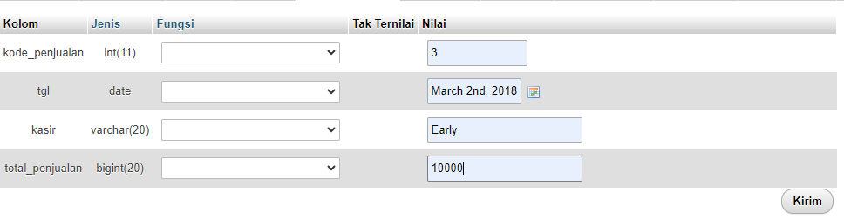

1. To Check Whether The Data Written Already Entered Into The Database How To: Select The Name Of The Table And Check The Value That Is In The Very Last Row.
2. Add Sales Data As Follows **<PROBLEMS 1>**,

|  |  |  |
| --- | --- | --- |
| O | Kode_Penjualan | = 3 |
| O | Date | = March 2nd,  2018 |
| O | Cashier | = Early |
| O | Total_Penjualan | = 10000 |

Whether Data Can Be Added? Explain Why!

**Answer :**

**Yes, Because The Previous Sales Code Doesn't Exist Yet**

1. Add The Following As Sales Data **<PROBLEMS 2>**,

|  |  |  |  |
| --- | --- | --- | --- |
| O | Kode_Penjual  An | = 2 |  |
| O | Date | = March 4th, 2018 | |
| O | Cashier | = Early | |
|  |  |  | 5 |
| O Total_Penjualan | | | = 20000 |

Whether Data Can Be Added? Explain Why!

**No, Because There Is A Duplication In The Sales Code**

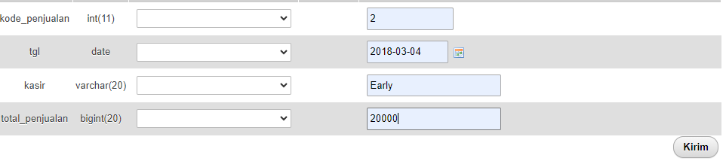

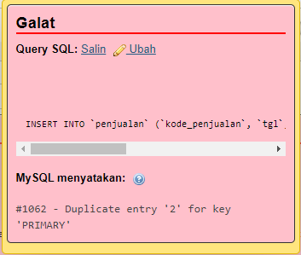

1. Explain How The Solution So That The Data In Problem 2 Can Be Added **<PROBLEMS 3>**

**The Solution Is To Replace The Sales Code With Another Number**

1. Add The Data Detail_Penjualan As Follows **<QUESTION 4>**,

|  |  |  |
| --- | --- | --- |
| O | Kode_Penjualan | = 2 |
| O | Item Code | = 3 |
| O | Price | = 5000 |
| O | Amount | = 5 |

Whether Data Can Be Added? Explain Why!

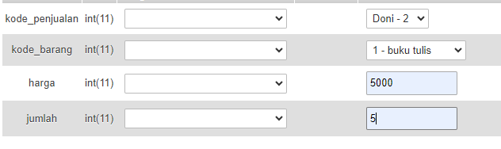

**Yes, Because In The Sales Data The Added Code Does Not Yet Exist**

1. Explain How The Solution So That Data On About 4 Can Be Added **<QUESTION 5>**
2. Explain What Can You Understand Of About 1-5 Associated With The Duplication And Inconsistencies In The Data

**Data Duplication Occurs When The Same Data Is Stored In Several Places In A Database, While Data Inconsistency Occurs When The Data In A System Or Database Is Inconsistent Or Out Of Sync.**

**<PROBLEMS 6>**

# Practicum 4

Objective: To Determine The Function Of The Relation Between Tables.

# Steps Pratikum 4

1. Add The Data Detail_Penjualan As Follows **<PROBLEMS 6>**,

|  |  |  |
| --- | --- | --- |
| O | Kode_Penjualan | = 10 |
| O | Item Code | = 1 |
| O | Price | = 5000 |
| O | Amount | = 5 |

Whether Data Can Be Added? Explain Why!

**No, Because There Is Still A Relationship Between The Sales Table And The Sales Details**

1. Show The Structure Of The Database And Remove The Hyphens Between The Sales Table And Detail_Penjualan How To Click A Circle Mark At The End Of The Line Between Sales And Detail_Penjualan Table, Then Select Delete.

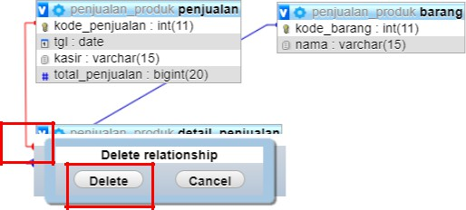

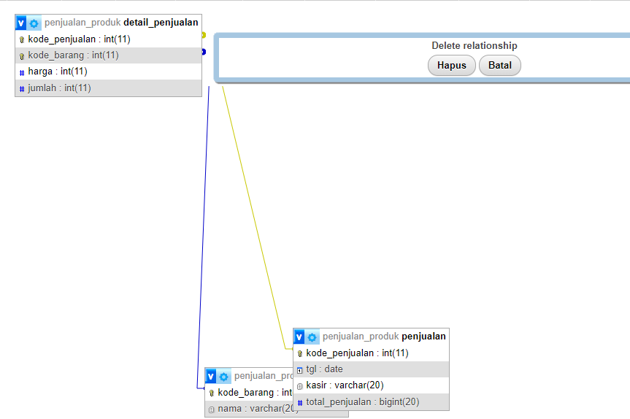

1. Repeat Step 1 On Practicum 4. Does The Data Can Be Added? Explain Why!

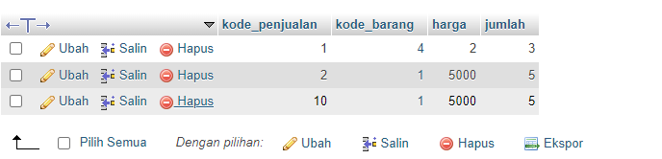

**Yes, You Can Because There Has Been A Cut In The Relationship Between The Sales Table Mark And Sales_Details. Each Table Is Related To Each Other. Relationships Are Created By Placing A Primary Key In The Table Being Related So That It Becomes A Foreign Key In That Table. So That The Data Base Can Be Added**

**- *Good Luck, Study Hard -***